Early Years Foundation Stage Over view topic 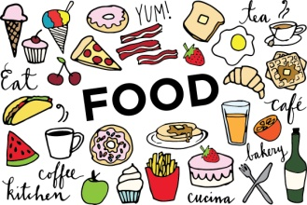

|  |  |  |  |
| --- | --- | --- | --- |
| Week 1  Rules  Image result for rules clipart | Week 2  Vegetables  Counting & Speaking  Image result for vegetables clipart | Week 3  Fruit  Counting  Image result for fruit clipart | Week 4  Icecream, smoothies  Writing  Image result for icecream clipart |
| Week 5  Gingerbread Man  Speaking  Image result for gingerbread man clipart | Week 6  Gingerbread Man  Cooking  Image result for gingerbread man clipart | Week 7  Little Red Hen Bread  Reading  Image result for bread clipart |  |
| Half Term | | | |
| Week 1  Little Red Hen Pizza  Frankie and Bennys Trip for reception  Writing  Pizza clip art free download free clipart images 3 | Week 2  Diwali Food  Rama and Sita  Being Imaginative  Physical Development  Image result for diwali food clipart | Week 3  Sweets  Counting  Writing  Image result for sweets clipart | Week 4  The Stick Man  Maths shape  Understanding the world  Image result for stick man julia donaldson |
| Week 5  The Stick Man  Personal development  Creative development  Image result for stick man julia donaldson | Week 6  The Christmas Story  Creative development  Reading  Image result for christmas story clipart | Week 7  Productions  Personal development  Creative development  Image result for mary and joseph story clipart |  |