Date | Declarative facts to revisit  (focus groups ) | Teacher focus for groups | Examples of how to support this (taken from Development Matters ) |   Maths in Continuous Provision
w/c 2.1 | Number recognition | Introducing 0  Composition of 4 & 5  Comparing numbers to 5  (recap) | Understand 1more/1less  Make predictions about what the outcome will be in stories, rhymes and songs if one is added, or if one is taken away. Provide ‘staircase’ patterns which show that the next counting number includes the previous number plus one.  Link symbol to cardinal value  Display numerals in order alongside dot quantities or tens frame arrangements. Play card games such as snap or matching pairs with cards where some have numerals, and some have dot arrangements. Discuss the different ways children might record quantities (for example, scores in games), such as tallies, dots and using numeral cards.  Composition  Focus on composition of 2, 3, 4 and 5 before moving onto larger numbers Provide a range of visual models of numbers: for example, six as double three on dice, or the fingers on one hand and one more, or as four and two with ten frame images. Model conceptual subitising: “Well, there are three here and three here, so there must be six.” Emphasise the parts within the whole: “There were 8 eggs in the incubator. Two have hatched and 6 have not yet hatched.” Plan games which involve partitioning and recombining sets. For example, throw 5 beanbags, aiming for a hoop. How many go in and how many don’t?  Compare  Provide collections to compare, starting with a very different number of things. Include more small things and fewer large things, spread them out and bunch them up, to draw attention to the number not the size of things or the space they take up. Include groups where the number of items is the same. Use vocabulary: ‘more than’, ‘less than’, ‘fewer’, ‘the same as’, ‘equal to’. Encourage children to use these words as well. Distribute items evenly, for example: “Put 3 in each bag,” or give the same number of pieces of fruit to each child. Make deliberate mistakes to provoke discussion. Tell a story about a character distributing snacks unfairly and invite children to make sure everyone has the same. | Numbers 0-5 (compare order, match quantities, composition)
w/c 9.1 | Subitising | Compare Mass | Model comparative language using ‘than’ and encourage children to use this vocabulary. For example: “This is heavier than that.” Ask children to make and test predictions. “What if we pour the jugful into the teapot? Which holds more?” | Numbers 0-5 (compare order, match quantities, composition)
w/c 16.1 | Cardinal value | Compare Capacity | Model comparative language using ‘than’ and encourage children to use this vocabulary. For example: “This is heavier than that.” Ask children to make and test predictions. “What if we pour the jugful into the teapot? Which holds more?” | Compare Mass
w/c 23.1 | Composition to 5 | 6, 7 and 8 (recap)  Making pairs | Understand 1more/1less  Make predictions about what the outcome will be in stories, rhymes and songs if one is added, or if one is taken away. Provide ‘staircase’ patterns which show that the next counting number includes the previous number plus one.  Link symbol to cardinal value  Display numerals in order alongside dot quantities or tens frame arrangements. Play card games such as snap or matching pairs with cards where some have numerals, and some have dot arrangements. Discuss the different ways children might record quantities (for example, scores in games), such as tallies, dots and using numeral cards.  Composition  Focus on composition of 2, 3, 4 and 5 before moving onto larger numbers Provide a range of visual models of numbers: for example, six as double three on dice, or the fingers on one hand and one more, or as four and two with ten frame images. Model conceptual subitising: “Well, there are three here and three here, so there must be six.” Emphasise the parts within the whole: “There were 8 eggs in the incubator. Two have hatched and 6 have not yet hatched.” Plan games which involve partitioning and recombining sets. For example, throw 5 beanbags, aiming for a hoop. How many go in and how many don’t?  Compare  Provide collections to compare, starting with a very different number of things. Include more small things and fewer large things, spread them out and bunch them up, to draw attention to the number not the size of things or the space they take up. Include groups where the number of items is the same. Use vocabulary: ‘more than’, ‘less than’, ‘fewer’, ‘the same as’, ‘equal to’. Encourage children to use these words as well. Distribute items evenly, for example: “Put 3 in each bag,” or give the same number of pieces of fruit to each child. Make deliberate mistakes to provoke discussion. Tell a story about a character distributing snacks unfairly and invite children to make sure everyone has the same.  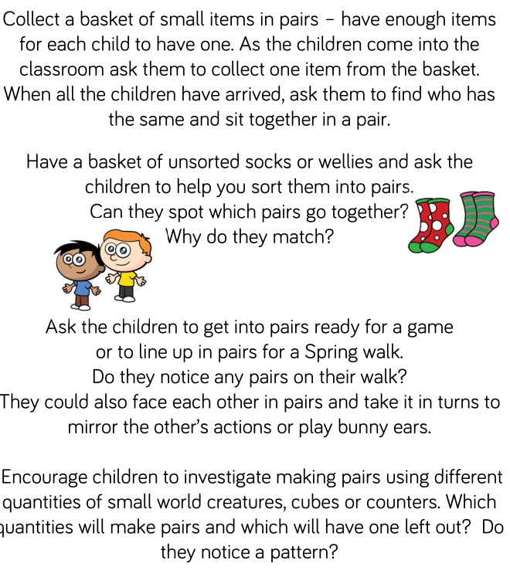 | Compare Capacity
w/c 30.1 | 1 more/1 less | Combining 2 groups | 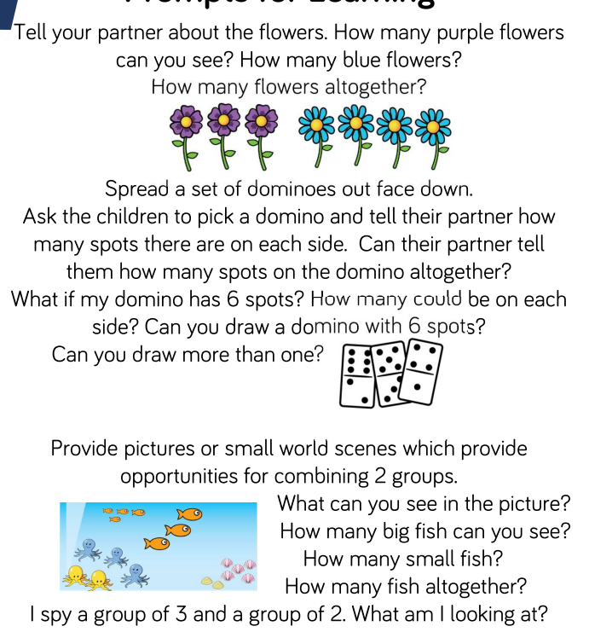 | 6, 7 and 8 (recap)  Making pairs
w/c 6.2 | Cardinal value | Length and height | Model comparative language using ‘than’ and encourage children to use this vocabulary. For example: “This is heavier than that.” Ask children to make and test predictions. “What if we pour the jugful into the teapot? Which holds more?” | Combining 2 groups
w/c 13.2 | Composition to 5 | Time | 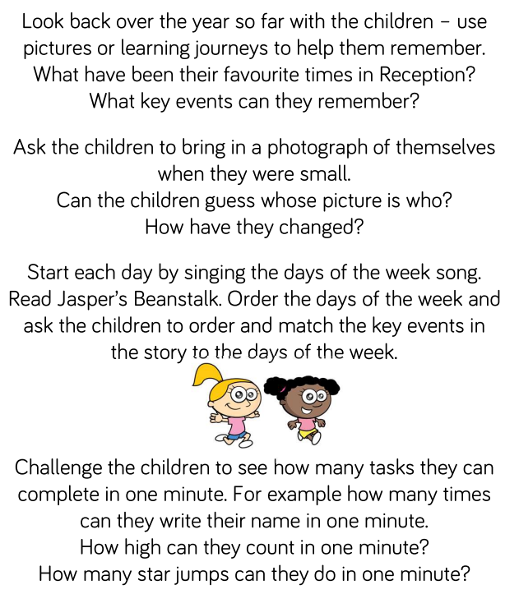 | Length and height
HT  w/c 20.2 | HALF TERM | HALF TERM | HALF TERM | HALF TERM
w/c 27.2 |  | 9 & 10 (recap)  Comparing numbers to 10 | Understand 1more/1less  Make predictions about what the outcome will be in stories, rhymes and songs if one is added, or if one is taken away. Provide ‘staircase’ patterns which show that the next counting number includes the previous number plus one.  Link symbol to cardinal value  Display numerals in order alongside dot quantities or tens frame arrangements. Play card games such as snap or matching pairs with cards where some have numerals, and some have dot arrangements. Discuss the different ways children might record quantities (for example, scores in games), such as tallies, dots and using numeral cards.  Composition  Focus on composition of 2, 3, 4 and 5 before moving onto larger numbers Provide a range of visual models of numbers: for example, six as double three on dice, or the fingers on one hand and one more, or as four and two with ten frame images. Model conceptual subitising: “Well, there are three here and three here, so there must be six.” Emphasise the parts within the whole: “There were 8 eggs in the incubator. Two have hatched and 6 have not yet hatched.” Plan games which involve partitioning and recombining sets. For example, throw 5 beanbags, aiming for a hoop. How many go in and how many don’t?  Compare  Provide collections to compare, starting with a very different number of things. Include more small things and fewer large things, spread them out and bunch them up, to draw attention to the number not the size of things or the space they take up. Include groups where the number of items is the same. Use vocabulary: ‘more than’, ‘less than’, ‘fewer’, ‘the same as’, ‘equal to’. Encourage children to use these words as well. Distribute items evenly, for example: “Put 3 in each bag,” or give the same number of pieces of fruit to each child. Make deliberate mistakes to provoke discussion. Tell a story about a character distributing snacks unfairly and invite children to make sure everyone has the same. | Time
w/c 6.3 |  | Bonds to 10 | Have a sustained focus on each number to and within 5. Make visual and practical displays in the classroom showing the different ways of making numbers to 5 so that children can refer to these. Help children to learn number bonds through lots of hands-on experiences of partitioning and combining numbers in different contexts, and seeing subitising patterns. Play hiding games with a number of objects in a box, under a cloth, in a tent, in a cave, etc.: “6 went in the tent and 3 came out. I wonder how many are still in there?” Intentionally give children the wrong number of things. For example: ask each child to plant 4 seeds then give them 1, 2 or 3. “I’ve only got 1 seed, I need 3 more.” Spot and use opportunities for children to apply number bonds: “There are 5 of us but only 2 clipboards. How many more do we need?” Place objects into a five frame and talk about how many spaces are filled and unfilled. | Numbers 0-10 (compare order, match quantities)  Comparing numbers to 10
w/c 13.3 |  | 3D shape (recap 2D from Autumn) | Encourage children to play freely with blocks, shapes, shape puzzles and shape-sorters. Sensitively support and discuss questions like: “What is the same and what is different?” Encourage children to talk informally about shape properties using words like ‘sharp corner’, ‘pointy’ or ‘curvy’. Talk about shapes as you play with them: “We need a piece with a straight edge.”  Language- ‘sides’, ‘corners’; ‘straight’, ‘flat’, ‘round’ | Bonds to 10
w/c 20.3 |  | 3D shape | Encourage children to play freely with blocks, shapes, shape puzzles and shape-sorters. Sensitively support and discuss questions like: “What is the same and what is different?” Encourage children to talk informally about shape properties using words like ‘sharp corner’, ‘pointy’ or ‘curvy’. Talk about shapes as you play with them: “We need a piece with a straight edge.”  Language- ‘sides’, ‘corners’; ‘straight’, ‘flat’, ‘round’  Select, rotate, manipulate  Provide high-quality pattern and building sets, including pattern blocks, tangrams, building blocks and magnetic construction tiles, as well as found materials. Challenge children to copy increasingly complex 2D pictures and patterns with these 3D resources, guided by knowledge of learning trajectories: “I bet you can’t add an arch to that,” or “Maybe tomorrow someone will build a staircase.” Teach children to solve a range of jigsaws of increasing challenge. Compose and decompose Investigate how shapes can be combined to make new shapes: for example, two triangles can be put together to make a square. Encourage children to predict what shapes they will make when paper is folded. Wonder aloud how many ways there are to make a hexagon with pattern blocks. Find 2D shapes within 3D shapes, including through printing or shadow play. | 2D shape/3D shape
w/c 27.3 |  | Pattern | Make patterns with varying rules (including AB, ABB and ABBC) and objects and invite children to continue the pattern. Make a deliberate mistake and discuss how to fix it. | 3D shape  Pattern

